Week One: Introduction to Agile Software Development
NAME | ADM. NUMBER | ATTENDANCE
Dickens Okoth | BSCCS/2024/53418 | Present
Harrison Mutua | BSCCS/2024/54032 | Present
Gakuo Muringi | BSCCS/2024/54739 | Absent
Margaret Kimani | BSCCS/2024/50172 | Absent
Joseph Rai | BSCCS/2024/53718 | Present

Project Name: Business Operations & Workflow Management Platform
Agile Methodology: Scrum Agile Methodology
Software Problem: Many businesses still manage work through:
- WhatsApp
- Excel
- Phone Calls
- Verbal Instructions
- Scattered Files
This creates:
Request →Waiting →Forgotten task →Follow-up →Approval →More waiting →Completion
The business often does not know:
- Who is handling a task?
- How long has it taken?
- Where is the bottleneck?
- Who approved it?
- What is still pending

Users of the System:
- Business Owner/Admin - Sets up the business, departments, branches, users, workflows, permissions, and business rules.
- Super Admin - Manages the entire SaaS platform, business subscriptions, system settings, and platform-level users.
- Manager/Supervisor - Assigns work, approves requests, monitors staff, handles escalations, and monitors departments’ performance.
- Employee/Staff - Receives and performs assigned tasks, submits requests, updates progress, and communicates through the system.
- Customer - Submits requests, tracks their status, and receives updates.
- Approver - Reviews and approves/rejects specific requests such as purchases, leave, and expenses.

System Capabilities/Functions
- Business Setup - The system should allow an organization admin to: register the business, create branches/departments, add employees, define roles/positions.
- User & Permission Management - Admins should be able to control what one can do, e.g., all users can view tasks.
- Workflow Creation - Admins should be able to define how a particular business process works, e.g., purchase requests.
- Task Management - Admins and managers should be able to create, assign, or drag tasks through stages.#
- Approval System - Managers should receive approval requests in order to: approve, reject, request changes, or delegate, and provide a reason/comment.

Most Important Feature of the System:
The System’s most important feature would be the Workflow Engine. This is because almost everything else in the system depends on it.
The workflow engine answers the fundamental question: “How does work move from being requested to being completed in this particular business?”

Possible Changes During Development:
Quite a lot can change during development, including:
- User roles and permissions - Initially, the system might have: admin, manager, and employee. However, stakeholders may require: HR, Finance, Branch Manager, Approver.
- Notification Methods - Initially, the MVP may use In-app notifications. However, changes may be made to allow SMS, Email, or Push Notifications.
- Mobile Experience - You might initially build a responsive web application. During development, users could reveal that employees primarily use phones. That could lead to a PWA/mobile-first redesign rather than immediately building a separate Android application.
- Security requirements - As the system develops, you may discover that employees shouldn't see requests from other departments. That could introduce:
- department-level permissions
- branch-level access
- record-level permissions
- stronger authentication
- audit logs
- session management
Security requirements often become clearer when the actual system is tested.
User Stories

1. Employee — Submit a Request
As an employee, I want to submit a business request through the system so that it can be assigned, processed, and tracked without relying on manual communication.
Acceptance criteria:
- Employee can create a request.
- Employee can select the request type.
- Employee can attach supporting documents.
- System generates a unique request number.
- Employee can track the request status.

2. Manager — Process & Approve Requests
As a manager, I want to view and approve requests assigned to me so that business processes can proceed without unnecessary delays.
Acceptance criteria:
- Manager can view pending requests.
- Manager can review request details and attachments.
- Manager can approve, reject, or request changes.
- System records the manager's action and timestamp.
- Approved requests automatically proceed to the next workflow stage.

3. Business Admin — Configure Workflows
As a business administrator, I want to create and configure workflows so that different business processes can follow the organization's actual procedures.

Acceptance criteria:
- Admin can create a workflow.
- Admin can define workflow stages.
- Admin can assign responsible roles/users to stages.
- Admin can define approval requirements.
- Admin can activate/deactivate workflows.
- Requests follow the configured workflow automatically.
Reasons Why Agile Would be Appropriate for the Project
- Requirements can change — Agile allows workflow requirements, user roles, and approval rules to be modified as the project develops.
- Incremental development — The system can be developed in small modules such as user management, workflow management, task management, and reporting.
- Continuous user feedback — Business owners, managers, and employees can test each iteration and provide feedback for improvement.
- Early delivery of working features — Important features such as request submission and workflow processing can be completed and demonstrated before the entire system is finished.
- Easy identification of problems — Testing each sprint helps detect errors and usability issues early rather than at the end of development.
Reasons For Selecting Scrum Methodology
- Sprint-based development — The system will be developed in short iterations, with each sprint delivering a functional feature.
- Prioritized product backlog — Features such as workflow management, task management, approvals, and reporting can be prioritized by importance.
- Regular feedback — Feedback can be collected after each sprint and used to improve subsequent development.
- Adaptability to changing requirements — Workflow rules, user roles, and system requirements can be changed as new needs are discovered.
- Continuous testing — Features are tested during each sprint instead of waiting until the end of the project.

WEEK TWO: Agile Development Methods
NAME | ADM. NUMBER | ATTENDANCE
Dickens Okoth | BSCCS/2024/53418 | Present
Harrison Mutua | BSCCS/2024/54032 | Present
Gakuo Muringi | BSCCS/2024/54739 | Absent
Margaret Kimani | BSCCS/2024/50172 | Absent
Joseph Rai | BSCCS/2024/53718 | Present

Features the Proposed System May Require
- User Registration & Login — allows users to securely access the platform.
- Business & User Management — allows administrators to manage the organization and its users.
- Request Management — allows employees to submit, track, and manage business requests.
- Workflow Management — allows administrators to create and configure business workflows.
- Task Management — assigns workflow tasks to responsible employees and tracks completion.
- Approval Management — allows authorized users to approve, reject, or request changes.
- Notifications — alerts users about new requests, assigned tasks, approvals, and updates.
- SLA & Escalation — monitors deadlines and escalates overdue tasks or requests.
- Dashboard & Reports — provides summaries and reports on business processes and performance.
- Audit Trail — records important system activities for accountability and tracking.

Prioritization of the Above Features
Priority | Feature | Reason
High | User Registration & Login | Provides secure access to the platform and identifies users.
High | Business & User Management | Establishes the organization and users who will operate the system.
High | Request Management | Provides the starting point for submitting and tracking business requests.
High | Workflow Management | Core feature that determines how requests move through business processes.
High | Task Management | Assigns workflow activities to responsible employees and tracks their completion.
High | Approval Management | Allows authorized users to approve or reject requests where approval is required.
Medium | Notifications | Keeps users informed about assignments, approvals, updates, and other activities.
Medium | SLA & Escalation | Helps monitor deadlines and handle delayed requests or tasks.
Low | Dashboard & Reports | Provides monitoring and reporting after the core workflow is functioning.
Low | Audit Trail | Provides detailed activity records and accountability after the main processes are established.
Iterations: Goals, Features, Tasks, Testing Activities, Feedback Source

Iteration 1 — System & User Foundation
Goal:
Establish the basic system structure and provide secure access for businesses and users.
Features:
- User Registration & Login
- Business & User Management
Tasks:
- Design the database structure.
- Create user registration functionality.
- Implement login and logout.
- Implement user authentication.
- Create business/organization profiles.
- Add, edit, and remove users.
- Configure basic user permissions.
Testing Activities:
- Test user registration.
- Test login and logout.
- Test invalid login credentials.
- Test creation and editing of business information.
- Test adding and managing users.
- Test user access permissions.
Feedback Source:
- Business administrators
- System users
- Development team

Iteration 2 — Core Workflow
Goal:
Allow employees to submit business requests and have them processed through defined workflows.
Features:
I. Request Management
II. Workflow Management
III. Task Management
Tasks:
- Create request types.
- Develop request submission forms.
- Generate unique request numbers.
- Create and configure workflow stages.
- Define the sequence of workflow stages.
- Assign tasks to responsible users.
- Create task dashboards.
- Implement task status tracking.
- Allow users to complete assigned tasks.
Testing Activities:
- Test request submission.
- Test request number generation.
- Test workflow creation.
- Test movement of requests between workflow stages.
- Test task assignment.
- Test task completion.
- Test request and task status updates.
Feedback Source:
- Employees
- Managers/Supervisors
- Business administrators

Iteration 3 — Approval & Process Control
Goal:
Enable authorization, communication, deadline monitoring, and escalation within business processes.
Features:
I. Approval Management
II. Notifications
III. SLA & Escalation
Tasks:
- Define approval stages.
- Implement approval requests.
- Allow authorized users to approve or reject requests.
- Allow users to request changes.
- Record approval decisions.
- Create notification mechanisms.
- Notify users about assignments and approvals.
- Define task/request deadlines.
- Monitor overdue tasks.
- Implement escalation rules.
- Notify responsible users when deadlines are exceeded.
Testing Activities:
- Test approval and rejection.
- Test multi-stage approvals.
- Test approval decision recording.
- Test notifications.
- Test deadline tracking.
- Test overdue request detection.
- Test escalation mechanisms.
Feedback Source:
- Managers
- Approvers
- Employees
- Business administrators

Iteration 4 — Monitoring & Accountability
Goal:
Provide visibility into business processes and maintain reliable records of system activities.
Features:
I. Dashboard & Reports
II. Audit Trail
Tasks:
- Design the main dashboard.
- Display request and workflow statistics.
- Create business process reports.
- Add filtering and searching.
- Create audit log functionality.
- Record important user activities.
- Record workflow and approval activities.
- Provide audit-log searching and filtering.
Testing Activities:
- Test dashboard statistics.
- Verify report accuracy.
- Test report generation.
- Test searching and filtering.
- Verify that important activities are recorded.
- Test audit-log retrieval.
- Test audit-log filtering.
Feedback Source:
- Business owners
- Managers
- Business administrators
- Auditors/Compliance Officers

Problems Arising from Poor Planning in Agile Software Development
- Poor team communication — Team members may misunderstand requirements or workflow responsibilities, causing incorrect features to be developed.
- Uncontrolled changes — Requirements may keep changing without proper prioritization, making it difficult to complete planned iterations.
- Poorly defined priorities — The team may spend time on less important features instead of focusing on the core Workflow Engine.
- Lack of customer availability — Without regular feedback from business users, the team may develop workflows that do not match actual business processes.
- Inexperienced team members — The team may misunderstand Agile practices and fail to manage iterations effectively.
- Weak documentation — Important workflow rules and decisions may not be recorded, making the system difficult to understand and maintain.

WEEK THREE: Lean Software Development
NAME | ADM. NUMBER | ATTENDANCE
Dickens Okoth | BSCCS/2024/53418 | Present
Harrison Mutua | BSCCS/2024/54032 | Present
Gakuo Muringi | BSCCS/2024/54739 | Absent
Margaret Kimani | BSCCS/2024/50172 | Absent
Joseph Rai | BSCCS/2024/53718 | Present

Identify Waste
1. What type of waste occurred?
Extra/overproduction and rework.
- The team developed a feature that the customer did not need.
- The team then had to rebuild the feature according to the actual requirement.

2. How could the team have discovered the requirement earlier?
The team could have involved the customer earlier and collected feedback before completing the feature. Regular reviews and discussions with users would have helped confirm whether the feature met the actual requirement.

3. How could Agile practices help?
Agile practices could help through short iterations, continuous testing, regular reviews, and customer feedback. The team could develop a small version of the feature, demonstrate it to the customer, receive feedback, and make changes before spending three weeks completing the wrong feature.

4. How could Lean thinking reduce the waste?
Lean thinking would focus on eliminating waste and delivering customer value. The team would validate the requirement before investing significant time in development and avoid building functionality that does not provide customer value. This would reduce both extra work and rework.

Lean Workflow
Step 1:Major activities required to deliver a feature
Feature: Request Management

Major Activity | Description
Identify requirements | Determine what users need when submitting and managing requests.
Define request types | Identify the different types of business requests the system will support.
Design the request form | Design the fields users need to provide when submitting a request.
Design the database | Create the data structure required to store requests.
Develop the request functionality | Build request creation, submission, viewing, and status tracking.
Integrate with workflow | Connect submitted requests to the appropriate workflow.
Test the feature | Check that requests can be created, submitted, tracked, and processed correctly.
Review with users | Allow employees/managers to review the feature and provide feedback.
Fix defects and improve | Correct problems discovered during testing and user review.
Deploy the feature | Make the completed feature available for actual use.

Activity flow
Requirements → Request Types → Form Design → Database Design → Development → Workflow Integration → Testing → User Review → Improvements → Deployment
Step 2: Classify Each Activity

Activity | Classification | Reason
Identify requirements | Customer Value | Ensures the feature addresses the user's actual needs.
Define request types | Customer Value | Determines the requests users can submit through the system
Design the request form | Customer Value | Creates the interface users need to submit requests.
Design the database | Necessary Support | Provides the structure needed to store request information.
Develop request functionality | Customer Value | Creates the actual request management functionality.
Integrate with workflow | Customer Value | Allows submitted requests to follow the business process.
Test the feature | Necessary Support | Helps ensure the feature works correctly and reduces defects.
Review with users | Customer Value | Confirms whether the feature meets user requirements.
Fix defects and improve | Necessary Support | Corrects problems and improves quality.
Deploy the feature | Customer Value | Makes the completed functionality available to users.

Step 3: Kanban Workflow
The required workflow is:
BACKLOG → READY → DOING → TESTING → REVIEW → DONE
Request Management Kanban Board
BACKLOG | READY | DOING | TESTING | REVIEW | DONE
Identify requirements | Define request types | Develop request functionality | Test request submission | User review | Completed requirements
Design database | Design request form | Workflow integration | Test status tracking | Manager review | Approved request feature
Deployment improvements | — | — | Fix defects | — | —

How it works
A Request Management task starts in BACKLOG, moves to READY when its requirements are clear, then to DOING during development. After development it moves to TESTING, then REVIEW for user feedback, and finally DONE when accepted.
This allows the team to visualize where work is accumulating, which is one of the purposes of the Lean/Kanban workflow described in the notes.

Step 4: Three Activities to Eliminate or Improve

1. Excessive documentation — Eliminate/Reduce
Only create documentation that is actually useful to the project.
Why: Unnecessary documentation consumes development time without directly contributing useful value.

2. Unnecessary approval delays — Improve
Reduce waiting time by ensuring the required people review requirements and features promptly.
Why: Waiting prevents other activities from progressing and creates delays.

3. Late defect discovery — Improve
Test the Request Management feature continuously instead of waiting until the feature is almost complete.
Why: Early testing makes problems easier to identify and fix.
These improvements address the Lean wastes of unnecessary processes, waiting, and defects/rework identified in the course notes.
Step 5: How Removing/Improving These Activities Improves Delivery

Activity Improved/Removed | Effect on Delivery
Excessive documentation | Reduces time spent on non-value-adding work, allowing the team to focus on development.
Unnecessary approval delays | Reduces waiting time and allows work to move through the workflow faster.
Late defect discovery | Finds problems earlier, reducing rework and the time required to fix defects.

Overall Lean Improvement
Before:
Requirements → Long documentation → Waiting for approval → Development → Late testing → Rework → Delivery
After:
Requirements → Quick validation → Development → Continuous testing → User review → Delivery
Task Delegation

NAME | ADM. NUMBER | ATTENDANCE | TASK MODULES
Dickens Okoth | BSCCS/2024/53418 | Present | Notifications, Reports
Harrison Mutua | BSCCS/2024/54032 | Present | Business & User Management
Gakuo Muringi | BSCCS/2024/54739 | Absent | Dashboard,
Margaret Kimani | BSCCS/2024/50172 | Absent | Audit trails
Joseph Rai | BSCCS/2024/53718 | Present | User Registration & Login

WEEK Four: SCRUM

Scrum Team Structure

Role | Student | Admission | Function
Product owner | Margaret Kimani | BSCCS/2024/50172 | Represents users/business needs and manages the Product Backlog.
Scrum master | Joseph Rai | BSCCS/2024/54718 | Facilitates Scrum events, supports the team, and helps remove impediments.
Developers | Harrison Mutua  Dickens Okoth  Gakuo Muringi | BSCCS/2024/54032  BSCCS/2024/53418  BSCCS/2024/54739 | Build, test, and deliver the working product Increment.

Product
Business Operations & Workflow Management Platform
Problem Being Solved
Businesses may rely on disconnected methods such as WhatsApp, email, spreadsheets, and paper to manage requests, approvals, tasks, and business processes.
This makes it difficult to:
- Track requests
- Know who is responsible for a task
- Monitor delays
- Manage approvals
- Track workflow progress
- Maintain reliable process records

Proposed Solution
A centralized platform where businesses can :

Submit requests→ Apply Workflows→ Assigns tasks→ Process tasks→ Approve/Reject→ Track Deadlines→ Escalate Delays→ Report→ Audit

Product Goal

To provide businesses with a centralized platform for managing requests, workflows, tasks, approvals, deadlines, notifications, and process records efficiently.

Initial Product Backlog

Priority | Backlog item
1 | User Registration and Login
2 | Business and User Management
3 | Request Management
4 | Workflow Management
5 | Task Management
6 | Approval Management
7 | Notifications
8 | SLA & Escalation
9 | Dashboard & Reports
10 | Audit Trail
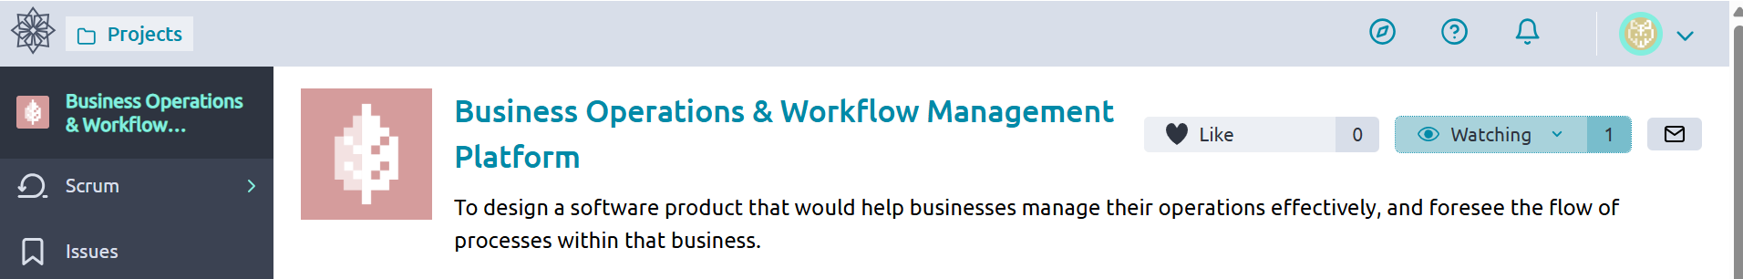
Fig. 1: Project dashboard

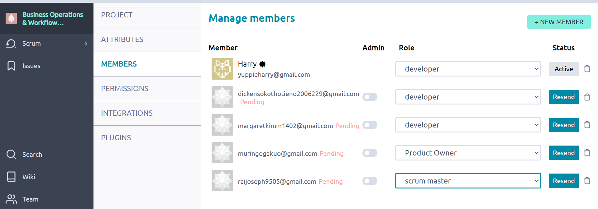
Fig. 2: Scrum team structure

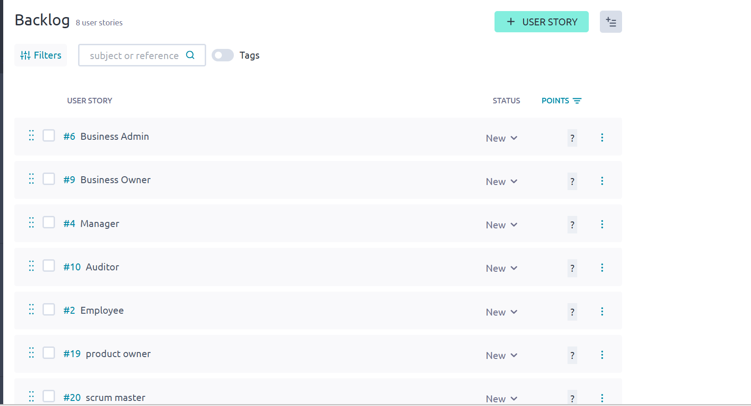
Fig. 3: Backlog: User stories

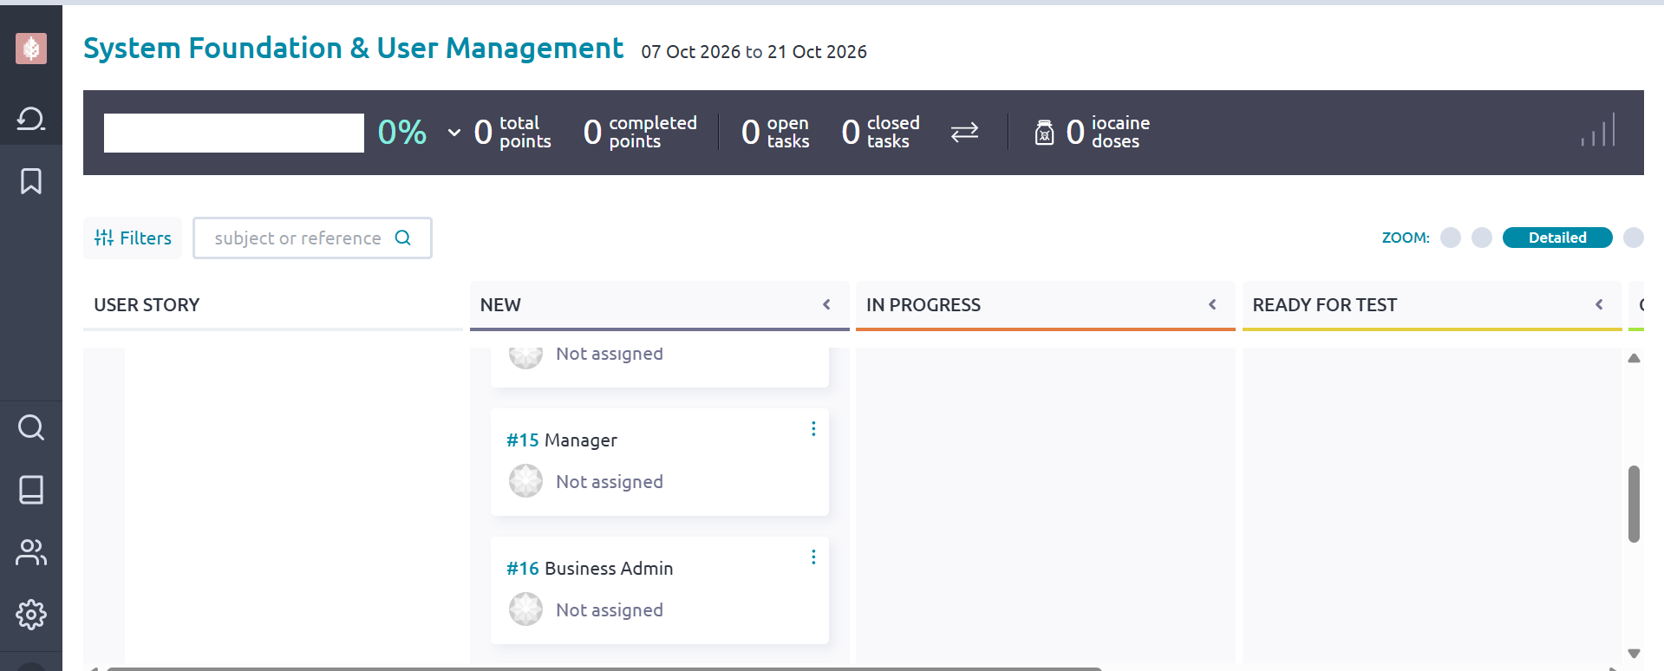

Fig. 4: Sprint

WEEK 5:SCRUM – PRIORITIZING, ESTIMATING AND PLANNING
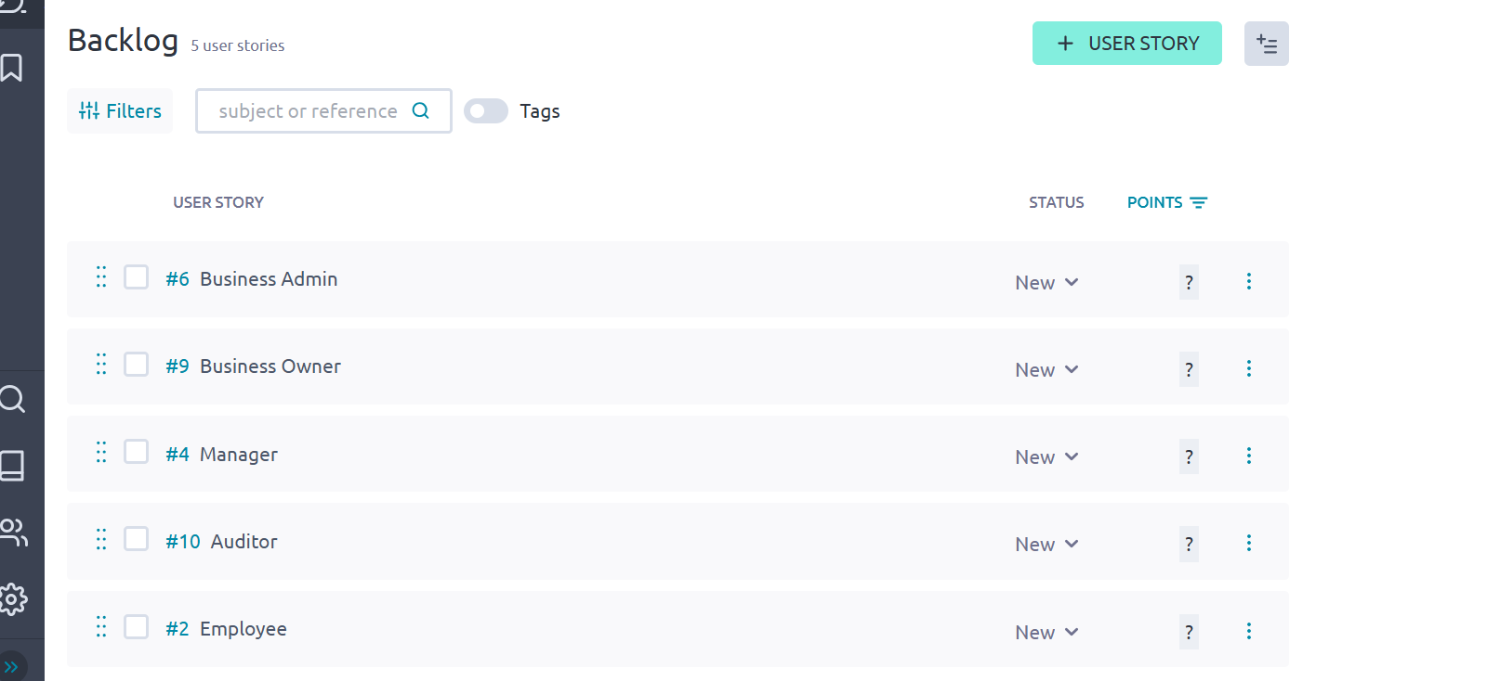
Fig 5.1: Product backlog

Fig. 5.2: User stories
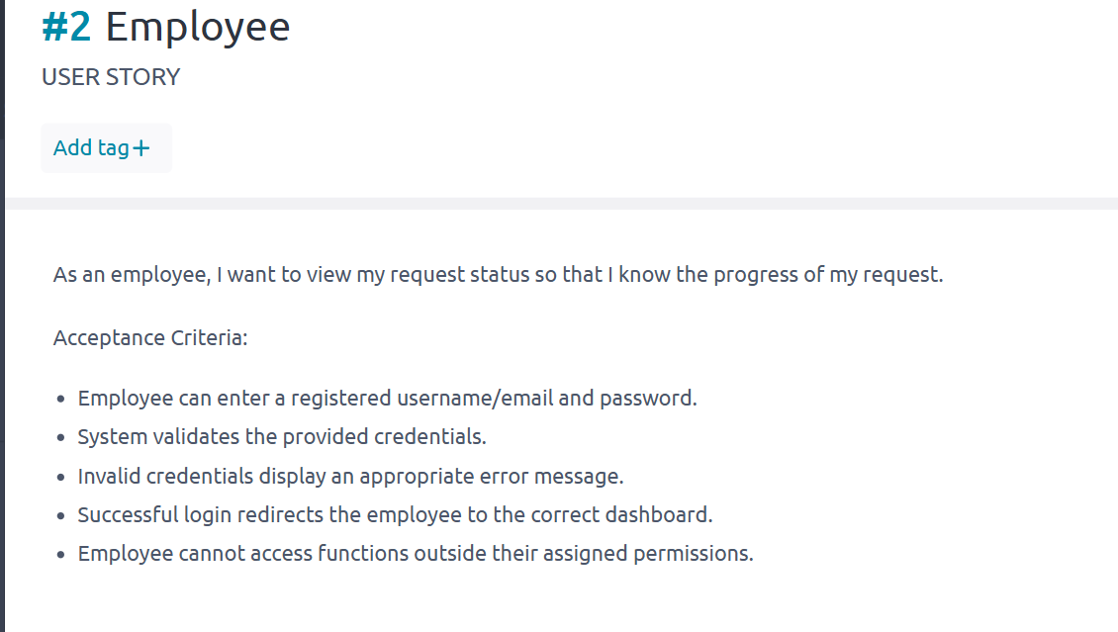
Fig 5.3: Acceptance criteria
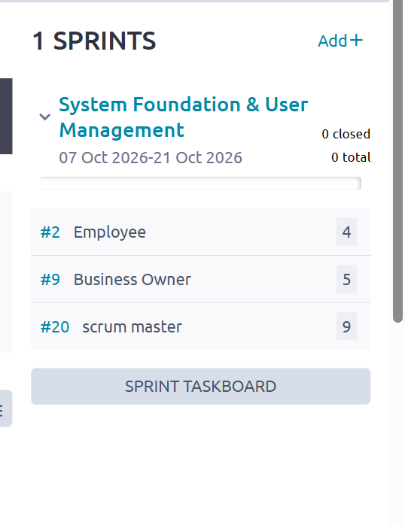
Fig. 5.4: story point estimates
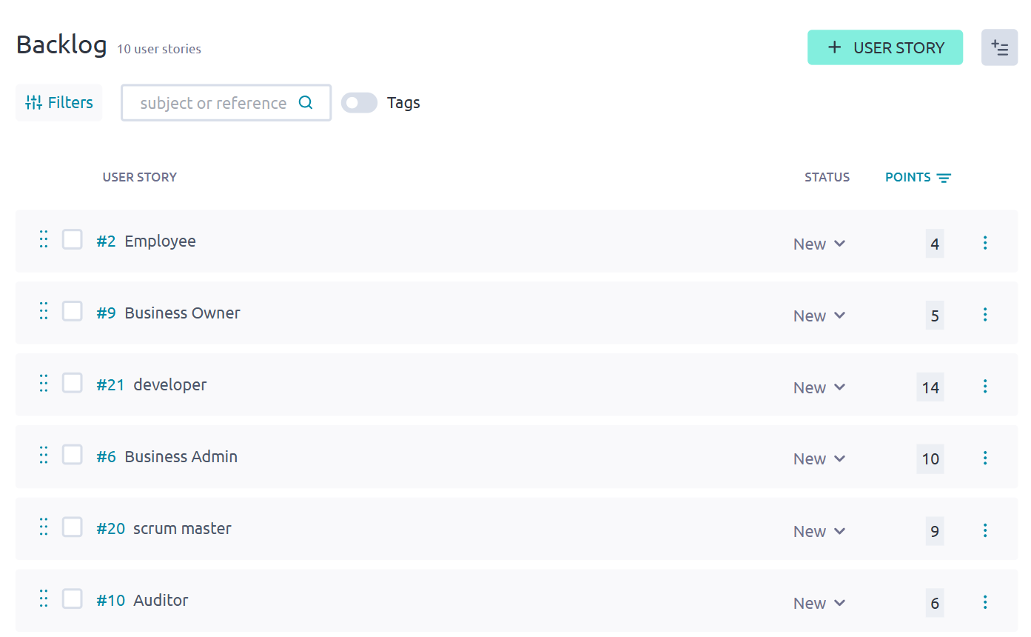
Fig. 5.5: prioritized backlog
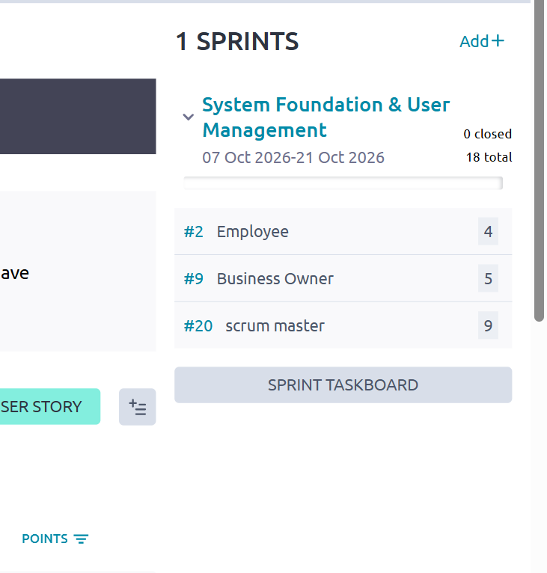
Fig. 5.6: sprint goal
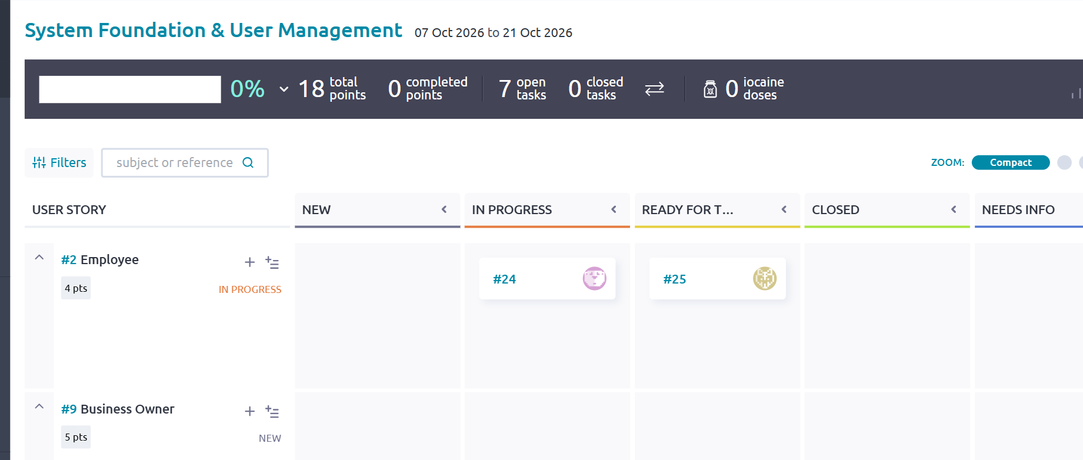
Fig.5.7: sprint backlog
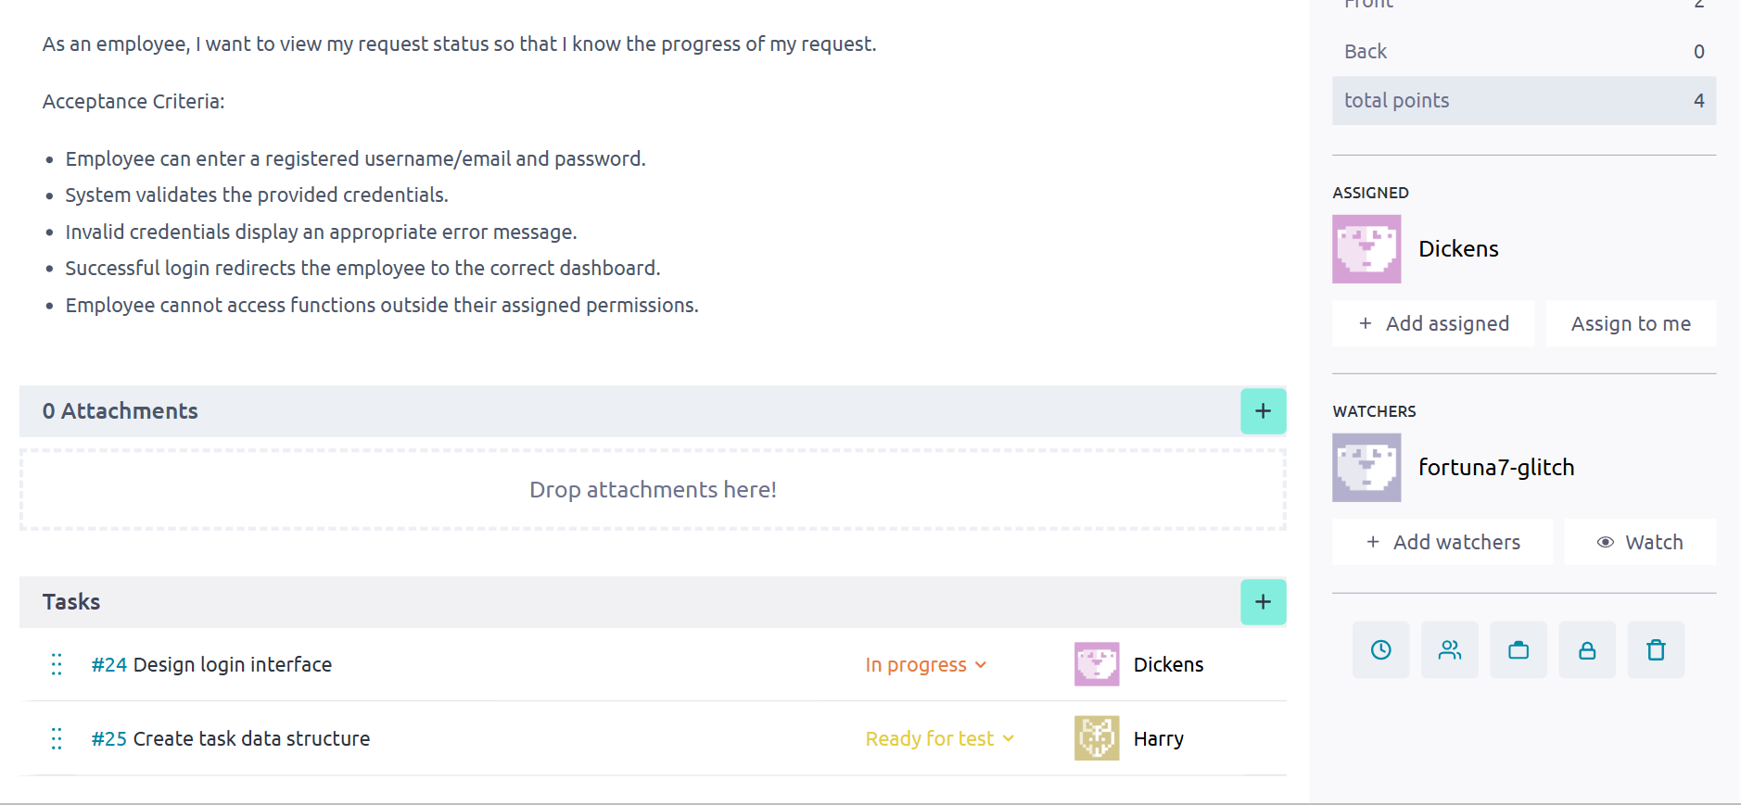
Fig. 5.8: Task breakdown

TEAM MEMBERS CERTIFICATES

Number | Admission Number | Name | Certification | Platform | Date Completed | Certificate ID | Verification link | Certificate Submitted | Verified
1. | BSCCS/2024/53718 | Joseph Rai | Agile Scrum Master | SCRUMStudy | 04/10/2026 | 10834562 | https://simpli-web.app.link/e/luCjL0PX6b
2. | BSCCS/2024/54032 | Harrison Mutua | Scrum Fundamentals Certified | SCRUMStudy | 05/10/2026 | 1196623 | https://www.scrumstudy.com/certification/verify?type=SFC&number=1196623
3. | BSCCS/2024/53418 | Dickens Okoth | Scrum Fundamentals Certified | SCRUMStudy | 03/10/2026 | 1196046 | https://www.scrumstudy.com/certification/verify?type=SFC&number=1196046
4. | BSCCS/2024/54739 | Gakuo Muringi
5. | BSCCS/2024/50172 | Margaret Kimani

